Project Design Phase-II
Technology Stack (Architecture & Stack)

Date | 27 February 2026
Team ID | LTVIP2026TMIDS35055
Project Name | Heart disease analysis
Maximum Marks | 4 Marks

Technical Architecture:
The Deliverable shall include the architectural diagram as below and the information as per the table1 & table 2
Example: Order processing during pandemics for offline mode
Reference: https://developer.ibm.com/patterns/ai-powered-backend-system-for-order-processing-during-pandemics/
Guidelines:
Include all the processes (As an application logic / Technology Block)
Provide infrastructural demarcation (Local / Cloud)
Indicate external interfaces (third party API’s etc.)
Indicate Data Storage components / services
Indicate interface to machine learning models (if applicable)


Table-1 : Components & Technologies:
S.No | Component | Description | Technology
 | User Interface | How user interacts with application e.g.  Web UI, Mobile App, Chatbot etc. | HTML, CSS, JavaScript / Angular Js / React Js etc.
 | Application Logic-1 | Logic for a process in the application | Java / Python
 | Application Logic-2 | Logic for a process in the application | IBM Watson STT service
 | Application Logic-3 | Logic for a process in the application | IBM Watson Assistant
 | Database | Data Type, Configurations etc. | MySQL, NoSQL, etc.
 | Cloud Database | Database Service on Cloud | IBM DB2, IBM Cloudant etc.
 | File Storage | File storage requirements | IBM Block Storage or Other Storage Service or Local Filesystem
 | External API-1 | Purpose of External API used in the application | IBM Weather API, etc.
 | External API-2 | Purpose of External API used in the application | Aadhar API, etc.
 | Machine Learning Model | Purpose of Machine Learning Model | Object Recognition Model, etc.
 | Infrastructure (Server / Cloud) | Application Deployment on Local System / Cloud  Local Server Configuration:  Cloud Server Configuration : | Local, Cloud Foundry, Kubernetes, etc.

Table-2: Application Characteristics:
S.No | Characteristics | Description | Technology
 | Open-Source Frameworks | List the open-source frameworks used | Technology of Opensource framework
 | Security Implementations | List all the security / access controls implemented, use of firewalls etc. | e.g. SHA-256, Encryptions, IAM Controls, OWASP etc.
 | Scalable Architecture | Justify the scalability of architecture (3 – tier, Micro-services) | Technology used
 | Availability | Justify the availability of application (e.g. use of load balancers, distributed servers etc.) | Technology used
 | Performance | Design consideration for the performance of the application (number of requests per sec, use of Cache, use of CDN’s) etc. | Technology used

References:
https://c4model.com/
https://developer.ibm.com/patterns/online-order-processing-system-during-pandemic/
https://www.ibm.com/cloud/architecture
https://aws.amazon.com/architecture
https://medium.com/the-internal-startup/how-to-draw-useful-technical-architecture-diagrams-2d20c9fda90d

Project Design Phase-I
Solution Architecture

Date | 27 February 2026
Team ID | LTVIP2026TMIDS35055
Project Name | Heart disease analysis
Maximum Marks | 4 Marks

Solution Architecture:
Solution architecture is a complex process – with many sub-processes – that bridges the gap between business problems and technology solutions. Its goals are to:
- Find the best tech solution to solve existing business problems.
- Describe the structure, characteristics, behavior, and other aspects of the software to project stakeholders.
- Define features, development phases, and solution requirements.
- Provide specifications according to which the solution is defined, managed, and delivered.

Example - Solution Architecture Diagram:

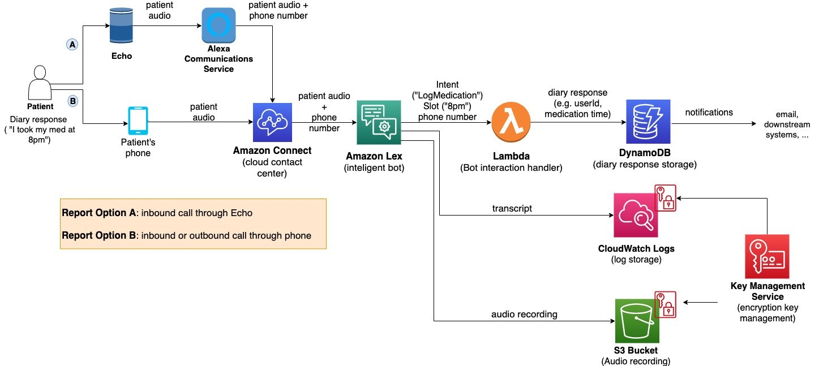
Figure 1: Architecture and data flow of the voice patient diary sample application
Reference: https://aws.amazon.com/blogs/industries/voice-applications-in-clinical-research-powered-by-ai-on-aws-part-1-architecture-and-design-considerations/

Project Design Phase-I
Proposed Solution Template

Date | 27 February 2026
Team ID | LTVIP2026TMIDS35055
Project Name | Heart disease analysis
Maximum Marks | 2 Marks

Proposed Solution Template:
Project team shall fill the following information in proposed solution template.
S.No. | Parameter | Description
 | Problem Statement (Problem to be solved) | Heart disease diagnosis is time consuming and complex due to large medical data and multiple risk factor
 | Idea / Solution description | A machine learning based application that analyzes patients data and predicts heart disease risk instantly
 | Novelty / Uniqueness | Novelty or Uniqueness combines prediction and visualisation in one platform
 | Social Impact / Customer Satisfaction | Supports early diagnosis and better decisions
 | Business Model (Revenue Model) | Subscription based healthcare solution
 | Scalability of the Solution | Cloud ready and expandable, can handle large datasets and be extended to other diseases

Project Design Phase-II
Solution Requirements (Functional & Non-functional)

Date | 27 February 2026
Team ID | LTVIP2026TMIDS35055
Project Name | Heart disease analysis
Maximum Marks | 4 Marks

Functional Requirements:
Following are the functional requirements of the proposed solution.
FR No. | Functional Requirement (Epic) | Sub Requirement (Story / Sub-Task)
FR-1 | User Registration | Registration through Form  Registration through Gmail  Registration through LinkedIN
FR-2 | User Confirmation | Confirmation via Email  Confirmation via OTP
FR-3 | User login | Login using email and password
FR-4 | Dataset upload | Upload CSV dataset
FR-5 | Data Analysis | Generate visualisations and charts
FR-6 | Prediction system | Predict heart disease using ML model

Non-functional Requirements:
Following are the non-functional requirements of the proposed solution.
FR No. | Non-Functional Requirement | Description
NFR-1 | Usability | Interface should be simple and user friendly
NFR-2 | Security | Data must be encrypted and protected
NFR-3 | Reliability | System should provide accurate predictions
NFR-4 | Performance | Prediction results should load within few seconds
NFR-5 | Availability | System should be available 24 by 7
NFR-6 | Scalability | System should handle large datasets

Project Title: Heart disease analysis Project Design Phase-I - Solution Fit Template Team ID: LTVIP2026TIMDS35055
Focus on J&P, tap into BE, understand RC
Explore AS, differentiate
Deﬁne CS, ﬁt into CC

or need to get the job done? What have they tried in the past? What pros & cons do these solutions have? i.e. pen and paper is an alternative to digital notetaking
AS
5. AVAILABLE SOLUTIONS
Which solutions are available to the customers when they face the problem
What constraints prevent your customers from taking action or limit their choices
of solutions? i.e. spending power, budget, no cash, network connection, available devices.
CC
6. CUSTOMER CONSTRAINTS
CS
1. CUSTOMER SEGMENT(S)
Who is your customer?
i.e. working parents of 0-5 y.o. kids

Explore AS, differentiate
Define CS, fit into CC

i.e. directly related: ﬁnd the right solar panel installer, calculate usage and beneﬁts; indirectly associated: customers spend free time on volunteering work (i.e. Greenpeace)
BE
7. BEHAVIOUR
What does your customer do to address the problem and get the job done?
RC
9. PROBLEM ROOT CAUSE
What is the real reason that this problem exists? What is the back story behind the need to do this job?
i.e. customers have to do it because of the change in regulations.
J&P
2. JOBS-TO-BE-DONE / PROBLEMS
Which jobs-to-be-done (or problems) do you address for your customers? There could be more than one; explore different sides.
Focus on J&P, tap into BE, understand RC
Focus on J&P, tap into BE, understand RC

Identify strong TR & EM
Identify strong TR & EM
Identify strong TR & EM | 3. TRIGGERS TR  What triggers customers to act? i.e. seeing their neighbour installing solar panels, reading about a more efﬁcient solution in the news. | 10. YOUR SOLUTION SL  If you are working on an existing business, write down your current solution ﬁrst, ﬁll in the canvas, and check how much it ﬁts reality.  If you are working on a new business proposition, then keep it blank until you ﬁll in the canvas and come up with a solution that ﬁts within customer limitations, solves a problem and matches customer behaviour. | - CHANNELS of BEHAVIOUR CH  - ONLINE  What kind of actions do customers take online? Extract online channels from #7  - OFFLINE  What kind of actions do customers take ofﬂine? Extract ofﬂine channels from #7 and use them for customer development.
Identify strong TR & EM | 4. EMOTIONS: BEFORE / AFTER EM  How do customers feel when they face a problem or a job and afterwards?  i.e. lost, insecure > conﬁdent, in control - use it in your communication strategy & design.

Project Planning Phase
Project Planning Template (Product Backlog, Sprint Planning, Stories, Story points)

Date | 27 February 2026
Team ID | LTVIP2026TMIDSS35055
Project Name | Heart disease analysis
Maximum Marks | 8 Marks

Product Backlog, Sprint Schedule, and Estimation (4 Marks)
Use the below template to create product backlog and sprint schedule
Sprint | Functional Requirement (Epic) | User Story Number | User Story / Task | Story Points | Priority | Team Members
Sprint-1 | Registration | USN-1 | As a user, I can register for the application by entering my email, password, and confirming my password. | 2 | High | Developer 1
Sprint-1 | Registration | USN-2 | As a user, I will receive confirmation email once I have registered for the application | 1 | High | Developer 1
Sprint-2 | Logging | USN-3 | As a user, I can register for the application through Facebook | 2 | Low | Developer 2
Sprint-1 | Prediction | USN-4 | As a user, I can register for the application through Gmail | 2 | Medium | Developer 2
Sprint-1 | Login | USN-5 | As a user, I can log into the application by entering email & password | 1 | High | Developer 1
Sprint-1 | Dashboard | USN-6 | As a user I can download prediction report | 2 | Medium | Developer 2

Project Tracker, Velocity & Burndown Chart: (4 Marks)
Sprint | Total Story Points | Duration | Sprint Start Date | Sprint End Date (Planned) | Story Points Completed (as on Planned End Date) | Sprint Release Date (Actual)
Sprint-1 | 20 | 6 Days | 24 Oct 2025 | 29 Oct 2025 | 20 | 29 Oct 2025
Sprint-2 | 20 | 6 Days | 31 Oct 2025 | 05 Nov 2025 | 20 | 05 Oct 2025
Sprint-3 | 20 | 6 Days | 07 Nov 2025 | 12 Nov 2025 | 18 | 12 Nov 2025
Sprint-4 | 20 | 6 Days | 14 Nov 2025 | 19 Nov 2025 | 20 | 19 Nov 2025
Sprint-5 | 20 | 6 Days | 12 Dec 2025 | 17 Dec 2025 | 20 | 17 Dec 2025
Sprint-6 | 20 | 6 Days | 1 Jan 2026 | 6 Jan 2026 | 18 | 6 Jan 2026

Velocity:
Imagine we have a 10-day sprint duration, and the velocity of the team is 20 (points per sprint). Let’s calculate the team’s average velocity (AV) per iteration unit (story points per day)
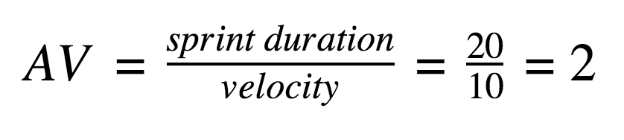

Burndown Chart:
A burn down chart is a graphical representation of work left to do versus time. It is often used in agile software development methodologies such as Scrum. However, burn down charts can be applied to any project containing measurable progress over time.

https://www.visual-paradigm.com/scrum/scrum-burndown-chart/
https://www.atlassian.com/agile/tutorials/burndown-charts

Reference:
https://www.atlassian.com/agile/project-management
https://www.atlassian.com/agile/tutorials/how-to-do-scrum-with-jira-software
https://www.atlassian.com/agile/tutorials/epics
https://www.atlassian.com/agile/tutorials/sprints
https://www.atlassian.com/agile/project-management/estimation
https://www.atlassian.com/agile/tutorials/burndown-charts

Ideation Phase
Define the Problem Statements

Date | 27th February 2026
Team ID | LTVIP2026TMIDS35055
Project Name | Heart disease analysis
Maximum Marks | 2 Marks

Customer Problem Statement Template:
Create a problem statement to understand your customer's point of view. The Customer Problem Statement template helps you focus on what matters to create experiences people will love.
A well-articulated customer problem statement allows you and your team to find the ideal solution for the challenges your customers face. Throughout the process, you’ll also be able to empathize with your customers, which helps you better understand how they perceive your product or service.

Reference: https://miro.com/templates/customer-problem-statement/
Example:

Problem Statement (PS) | I am (Customer) | I’m trying to | But | Because | Which makes me feel
PS-1 | A Doctor | Predict heart disease quickly | Manual analysis | Large patient data | Stressed
PS-2 | A researcher | Analyze heart disease pattern | Data is scattered | No proper visualisation tools | Frustrated

Ideation Phase
Empathize & Discover

Date | 27 February 2026
Team ID | LTVIP2026TMIDS35055
Project Name | Heart disease analysis
Maximum Marks | 4 Marks

Empathy Map Canvas:
An empathy map is a simple, easy-to-digest visual that captures knowledge about a user’s behaviours and attitudes.

It is a useful tool to helps teams better understand their users.
Creating an effective solution requires understanding the true problem and the person who is experiencing it. The exercise of creating the map helps participants consider things from the user’s perspective along with his or her goals and challenges.
Example:


Reference: https://www.mural.co/templates/empathy-map-canvas

Example: Food Ordering & Delivery Application

Ideation Phase
Brainstorm & Idea Prioritization Template

Date | 27 February 2026
Team ID | LTVIP2026TMIDS35055
Project Name | Heart disease analysis
Maximum Marks | 4 Marks

Brainstorm & Idea Prioritization Template:
Brainstorming provides a free and open environment that encourages everyone within a team to participate in the creative thinking process that leads to problem solving. Prioritizing volume over value, out-of-the-box ideas are welcome and built upon, and all participants are encouraged to collaborate, helping each other develop a rich amount of creative solutions.
Use this template in your own brainstorming sessions so your team can unleash their imagination and start shaping concepts even if you're not sitting in the same room.
Reference: https://www.mural.co/templates/brainstorm-and-idea-prioritization
Step-1: Team Gathering, Collaboration and Select the Problem Statement


Step-2: Brainstorm, Idea Listing and Grouping


Step-3: Idea Prioritization


